**Project 5 Part 2 Canny Edge Hysteresis**

Name: Randy Fu Period: 5 Date: 1/11

Is your lab name l052?(lowercase L followed by digits 052) Yes

**Did you test your code on a school terminal using c++11?** Yes

(you compile like this: g++ -std=c++11 -Wall -o l052 l052.cpp)

Does your main method call only part2()? Yes

Did you create a gray image? Yes

Did you apply the Sobell operator? Yes

Did you apply a double threshold/hysteresis? Yes

Paste here **4 clear pictures** of the initial picture, the gray image (obtained in part1), the image obtained after applying single threshold (obtained in part1) and the image after applying hysteresis&double threshold. (you can obtain all images by activating both part1 and part 2 when creating this document)

(when you submit you will deactivate part1 so the runs are faster when I test!!)

Part 2

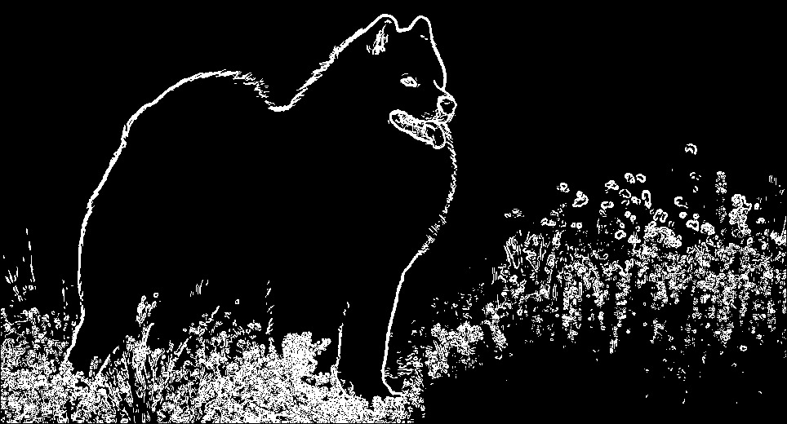

Part 1

